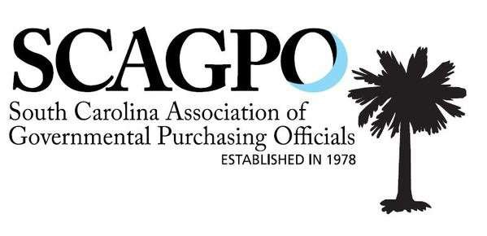

September Quarterly Training
Agenda
September 19, 2024

8:00 – 8:30 Sign In

8:30 – 10:00 Risk Management
Stacy Gregg, NIGP-CPP, CPPO, CPPB
Procurement Director, SC State University
(UPPCC Domain I.A, NIGP Focus: Policy, Legislation, Oversight)

10:00 – 10:15 Break

10:15 – 11:45 The Compendium Update and Responsiveness & Responsibility

Keith McCook, Esq

South Carolina State Fiscal Accountability Authority
(UPPCC Domain I.A, NIGP Focus: Policy, Legislation, Oversight)

11:45 – 1:00 Lunch

1:00 – 2:30 Contract Administration
Delbert H. Singleton, Jr., Esq
Secretary and Assistant Executive Director
South Carolina State Fiscal Accountability Authority

2:30 – 2:45 Break

2:45 – 3:00 Professional Development Updates

3:00 – 4:30 Contract Controversies
Michael Montgomery, Esq
Montgomery Willard, LLC
(UPPCC Domain I.A, NIGP Focus: Policy, Legislation, Oversight)

Recommended Contact 6 Hours
Final determination to be made by the UPPCC

